Hello, Welcome to the Istanhack. We are glad to see you here. Before we start, we want to give some intorductions. You can choose 2 sections of the case.

**CASE 1 🡪 GEAR BOUNTY – 5000$**

You can develop a game on Gear. You will have to develop in Polkadot on Gear , using basic Rust or C++ language. You can check the details from there;

* <https://wiki.gear-tech.io/docs/examples/prerequisites/>
* <https://www.gear-tech.io/developers>

## Gear’s Gaming track for InstaHack Istanbul 2022

**Description:**

Inspired by a well-known and loved table game, we created a “Syndote”. Totally on-chain game for developers to try their skills in building algorithms to win.

We will build the master contract containing the game's main rules and card information (cell cost, special cells: jail, lottery, etc).

The master contract will have enough gas reservation for automatic play. Before each round, the master contract checks the amount of gas; if it is not enough, it will send a message to the game admin to request another gas reservation.

As a hackathon participant, you will have to build your playing algorithm as a primary task if you want to amplify the number you score; several other game features, such as NFT integration, loan system, etc., could be done.

All these game features could be easily transformed into products by themselves later on.

We also want to support you as much as possible so you will be able to use all our [examples](https://wiki.gear-tech.io/docs/examples/prerequisites/), and we will try to provide you with some additional educational and explanatory materials. As well as, our mentors would be there for you.

**This is how the game will look:**

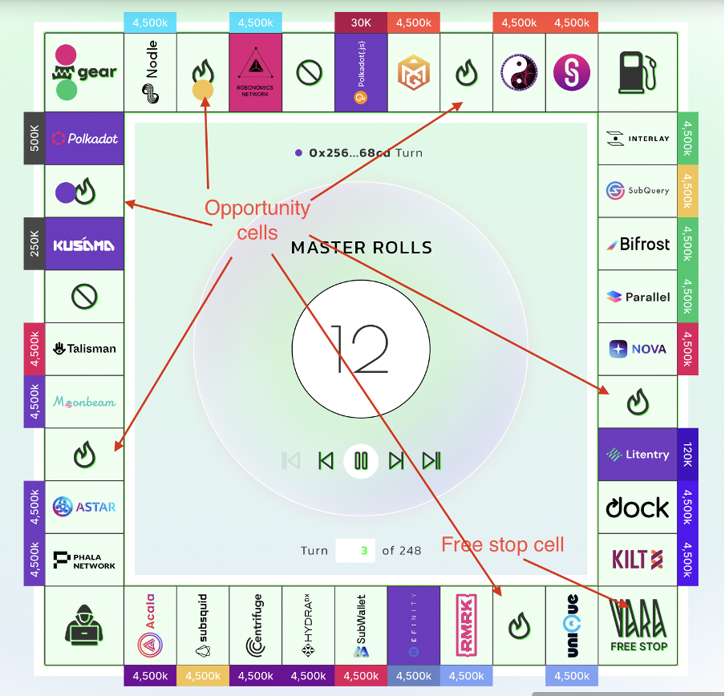

### Different internal Challenges

All these challenges will be described better during the hackathon, but the idea is that different projects can do several tasks for each task, and there is a fork in the number of points that they can get.

|  |  |  |
| --- | --- | --- |
| Name | Description | Points |
| Syndote game | Play, Learn & Earn!  Create & deploy a unique game strategy.  Customize an algorithm template and compete with other developers! | 2 - 6 |
| Build custom gameplay mechanics for a “Free stop” & Opportunity cells (see screenshot above)  (Difficulty: Easy) | Ideas for inspiration:  - Game of chance [<https://wiki.gear-tech.io/docs/examples/lottery>];  - Jackpot;  - Teleportation;  - Balance slashing/airdrops;  - *Your cool idea.* | 4 - 8 |
| Extension for Syndote  (Difficulty: Medium) | Ideas for inspiration:  - Automated gNFT in-game public auction - re-use existing Dutch-auction implementation [<https://wiki.gear-tech.io/docs/examples/dutch-auction>];  - Betting layer for viewers and participants;  - *Your cool idea.* | 6 - 12 |
| Extension for Syndote  (Difficulty: Hard) | Ideas for inspiration:  - gNFT Syndote lending solution; - SDNT lending (Bank-to-Algorithm / Algorithm-to-Algorithm);  - Algorithm-to-Algorithm trade offers within an on-chain game session (trade spread limit 50%). - *Your cool idea.* | 8 - 16 |

### Judging

Each task will be judged through the below-listed criteria in a matrix way; after that, the final score will be calculated.

**Potential impact**

●  Other Gear applications could re-use this function;

**Creativity**

●  Gear apps repo don’t cover this functionality;

●  Innovative solution.

**Gear usability**

●  What’s the added value of using Gear VM?

**Code quality**

●  Code works? Is it secure? Is the gas usage optimized?

●  Functionality behavior is well documented.

**UX / UI**

●  Is interacting with a new game module user-friendly?

**About Gear:**

The Gear Protocol is a Substrate-based smart-contract platform that enables anyone to develop and run a dApp in a matter of minutes. The Gear Protocol is the most developer-friendly way to implement smart contracts with arbitrary logic and of any complexity. Gear smart-contracts run as WebAssembly programs so they can be compiled from many popular programming languages, such as Rust, C, C++, and many more.

The protocol ensures very minimal, intuitive, and sufficient APIs for implementing programs and running them on multiple networks without having to rewrite them. From a technological point of view, the Gear Protocol is distinguished by fundamentally new features that enable you to create asynchronous programs with a completely new and previously unattainable user experience, namely - the Actor model for communication, the persistent memory concept, and WebAssembly execution environment. The protocol dictates what actors should look like as communicating entities.

The Gear Protocol will assist with the transition to mass use of Web3 technologies by enabling the running of innovative dApps, microservices, middleware, and open APIs.

**CASE 2 🡪 SUPER TEAM – 5000$ BOUNTY**

Or you can solve problem of refugee for Superteam & UNHCR on Solana. Here is the case;

**About UNHCR:**

United Nations High Commissioner for Refugees - the UN Refugee Agency (UNHCR), is a global organization dedicated to saving lives, protecting rights and building a better future for refugees, forcibly displaced communities and stateless people. We work to ensure that everybody has the right to seek asylum and find safe refuge, having fled violence, persecution, war or disaster at home. Since 1950, we have faced multiple crises on multiple continents, and provided vital assistance to refugees, asylum-seekers, internally displaced and stateless people, many of whom have nobody left to turn to. We help to save lives and build better futures for millions forced from home. Our protection, shelter, health and education has been crucial, healing broken pasts and building brighter futures.

**REGISTRARION:**

**Why Registration is Important:**

Access to registration is critical to the realization of the fundamental right to seek asylum, and should be available on a voluntary basis to all persons seeking international protection without discrimination, except fighters and citizens of country of asylum, who are not admissible. Registration should be physically, economically and socially accessible to all asylum-seekers and refugees within three months of their arrival on a territory, irrespective of their age, gender, race, religion national or ethnic origin, political or other opinion, sexual orientation and gender identity, disability or any other health or personal status. In addition, registration processes must be free of charge and no fees should be charged for related activities, such as documentation or the taking of photos.

**What is the problem?**

Globally, more than 1 billion people lack identity papers. In our modern world this excludes from services and socio-economic participation, it limits access, for example, to work, housing, a mobile phone and a bank

account. In fact, the lack of a documented identity constitutes for vulnerable and already marginalized people a constant risk of transgressing the lines between legal and illegal. Most people affected by the lack of legal identity live in their own country and may have chances of obtaining identity documents if specific measures are put in place in their favour.

But what if you don’t live in your home area but abroad, if you are a foreigner, migrant, asylum seeker or refugee? In this situation, protection risks are high while chances of obtaining a legal and recognized identity and inclusion are low.

**Question:**

Given the above, what would be innovative ways to create a self-managed Digital Wallet for refugees and introduce Document Verification Registers (e-Registry and e-Apostille) of UNHCR’s Persons of Concern to implement its strategy on [Digital Identity and Inclusion](https://eur02.safelinks.protection.outlook.com/?url=https%3A%2F%2Fwww.unhcr.org%2Fblogs%2Fwp-content%2Fuploads%2Fsites%2F48%2F2018%2F03%2F2018-02-Digital-Identity_02.pdf&data=05%7C01%7CTOROS%40unhcr.org%7C5fbf2183d4ff4c8b20be08dac26b9a08%7Ce5c37981666441348a0c6543d2af80be%7C0%7C0%7C638036064644556155%7CUnknown%7CTWFpbGZsb3d8eyJWIjoiMC4wLjAwMDAiLCJQIjoiV2luMzIiLCJBTiI6Ik1haWwiLCJXVCI6Mn0%3D%7C3000%7C%7C%7C&sdata=kH9XQpeEytomtkis6kR1HOXqzBU7fDfoKMkz1du9efQ%3D&reserved=0) and contribute to offering new opportunities for refugees?

**CASH-BASED INTERVENTIONS (CBI)**

**Why CBI is Important:**

CBI provides persons of concern greater dignity of choice in meeting their needs. Experience and evidence highlight that CBI increases protection outcomes, facilitates inclusion and solutions, and improves efficiency and effectiveness in delivery of aids. As the preferred modality of assistance of persons of concern, CBI also contributes to the local economy and fosters positive relations with host communities. UNHCR has between 2016-2020 delivered some USD 3 billion in cash assistance to 25 million recipients in 100 countries. Most of UNHCR’s CBI (95 per cent) is disbursed without restrictions giving the choice to the recipients on how best to meet their own needs

We are currently exploring the possibility of delivering USDC to internally displaced and refugees affected by the Ukraine situation. We have an MVP and are in the testing phase.

**What is the problem:**

Learning suggests that CBI implementation may be challenging in specific and fragile contexts due to political or other impediments. Still, significant opportunities exist to further expand the systematic and rapid use of CBI in UNHCR’s response while maximizing its impact on people’s wellbeing and protection, and opportunities for inclusion in national systems and solutions. Developments and innovations in CBI happen fast and regularly. UNHCR must continue to be ahead of the curve, maximizing new developments, partnerships and agile approaches building on continued investment in strong organizational CBI capacity.

**Question:**

Given the ethos of banking the unbanked and decentralizing financial access to ensure inclusion of different populations globally, how can Blockchain technology be used to deliver aid to different populations globally? (Keeping in mind the financial/technological literacy vs the complexity of current systems). Here we need to think of ways to generate large pay files to a significant number of individuals, have fast/cheap transactions and ensure secure ownership and custody of funds with possibility of spending/cashing out and transacting. Also, given the sensitivity of refugee identification, the requirements need to be as minimal as possible ensuring anonymity and data protection. Finally, as a humanitarian agency we value accountability and traceability, remaining blockchain agnostic and focusing on the use of blockchain for good.

*** You have to do your presentation in **ENGLISH**

Good Luck 😊